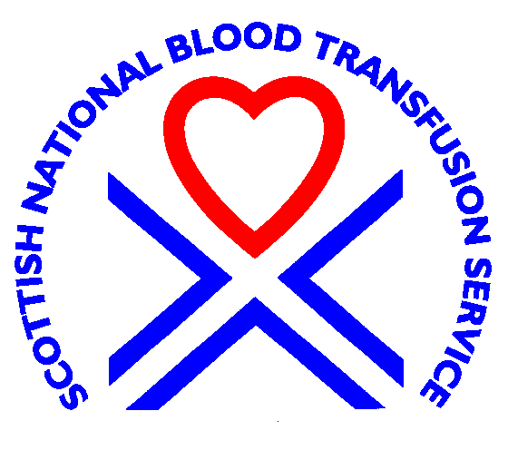  Edinburgh & SE Scotland  Blood Transfusion Centre |  | 

NHS NATIONAL SERVICES SCOTLAND

PERSON SPECIFICATION

Factor | Essential | Desirable
Experience | Experience of clinical and laboratory haematology and / or transfusion medicine. | Evidence of development of a specialist interest.
Qualifications | MBBS or equivalent  GMC Registration  Specialist Registration | MRCP or equivalent  MRCPath or equivalent  MD or PhD  Evidence of research activity
Training | Experience of undergraduate teaching. | Knowledge of post graduate training structure and practice.
Knowledge and skills | Ability to perform as an independent clinical consultant.  Ability to lead a clinical team in the environment of a teaching hospital with attention to training issues.  Evidence of previous research activity at undergraduate or postgraduate level. | Experience of budget management.  Present research activity or plans.
Personal Qualities | Good team member who communicates well with staff and patients. Good interpersonal skills.  Commitment to improving quality and safety | Leadership, organisational and management skills.  Evidence of initiative in service and research development.
General | Participation in audit.

